A000-Eur-France-Le Grand Pressigny-Mousterian-Hand Axe-Black Flint

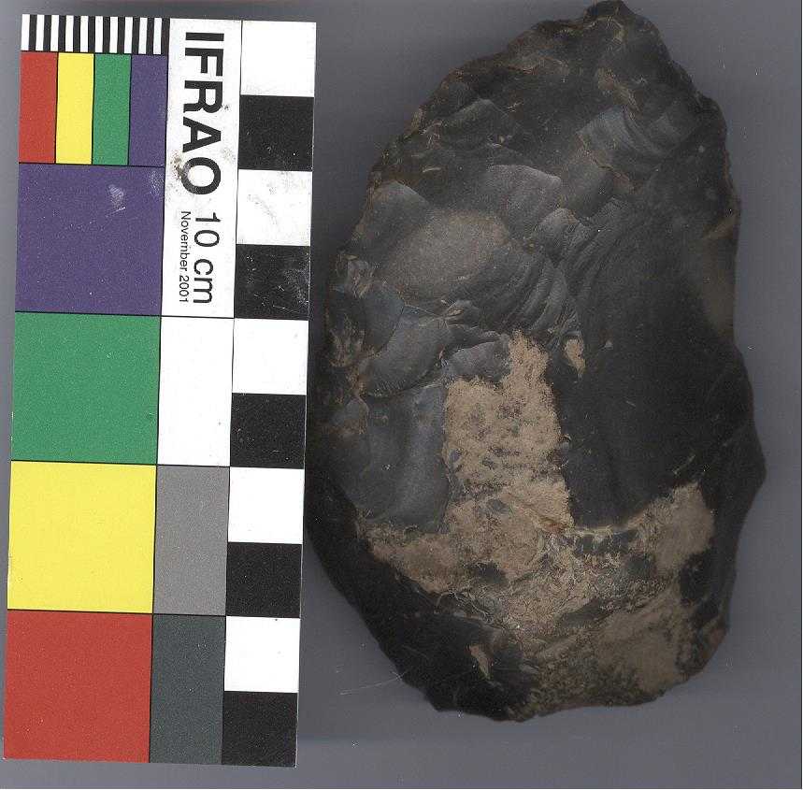

Fig. 1. Dis-Eur-France-Le Grand Pressigny-Mousterian-Hand Axe-Black Flint

Case no. 1